Tracing Li Bai: A Digital Humanities Journey Through the Life and Poetry of China’s “Banished Immortal”
Introduction
This project explores Li Bai as an important figure in Chinese literary and cultural history by examining the relationship between his life, his travels, and his poetry. By connecting his poems with his historical background, geographical movements, and personal experiences, the project aims to present a fuller understanding of his literary achievement and cultural significance.
Questions
How did Li Bai’s life experiences and travels shape the themes, imagery, and style of his poetry?
Why it matters
This project matters because it helps us understand Li Bai not only as a great poet, but also as a historical and cultural figure shaped by travel, place, and experience. It also shows how classical Chinese poetry can be reinterpreted in meaningful ways through digital humanities.
Expected Results
A digital humanities platform that presents Li Bai’s life, travels, and major poems through maps, timelines, text analysis, and interactive visual materials.

Technical Framework Overview
From a technical perspective, this study employs a purpose-built digital tool stack to systematically investigate Li Bai’s cultural legacy. The integrated workflow is designed to acquire multi-source data (e.g., CBDB, CHGIS, Chinese Text Project), transform heterogeneous, unstructured historical sources into cohesive, multimodal scholarly narratives, and ensure long-term preservation. Below is a functional overview of each core phase and tool’s role within the research pipeline:
Core Digital Tools and Functions
1. ChatGPT/Gemini & Human QC (Data Processing): Extracts entities (time, locations, relations) from unstructured sources (CBDB, GitHub). Rigorous human verification ensures historical accuracy, outputting standardized TEI XML and CSV formats.
2. Voyant Tools (Text Analytics): Ingests TEI XML to analyze lexical distributions and thematic shifts (e.g., "moon", "wine") across Li Bai’s distinct biographical phases.
3. StoryMapJS (Geospatial Narrative): Maps verified CSV geodata (via CHGIS) to construct an interactive itinerary, linking Li Bai’s travels with localized poetic outputs.
4. Flourish (Data Visualization): Transforms structured CSV data into dynamic, animated charts to highlight macro-level trends in his regional and temporal productivity.
5. Platform & Repository (Output & Preservation): Integrates all visualizations into a unified digital archive, and deposits underlying datasets into an Institutional Repository aligned with FAIR principles and DOIs.
Technical Data Flow and Architecture
Multi-source academic data acquisition (CBDB & GitHub for raw metadata and unstructured texts + CHGIS & Chinese Text Project for standardized geocodes and texts) → Data processing and quality control (utilizing ChatGPT/Gemini for AI entity extraction, followed by human-in-the-loop verification and cross-referencing to generate interoperable TEI XML & CSV formats) → Core analysis and visualization rendering (importing TEI XML into Voyant Tools for semantic text mining + importing CSV into StoryMapJS for geospatial trajectory mapping + importing CSV into Flourish for animated productivity metrics) → Final outcome integration and preservation (constructing the integrated "Interactive Digital Archive" platform, and ensuring long-term archiving via an Institutional Repository aligned with DOIs and FAIR principles).
The tool stack of this research is shown in the following figure.
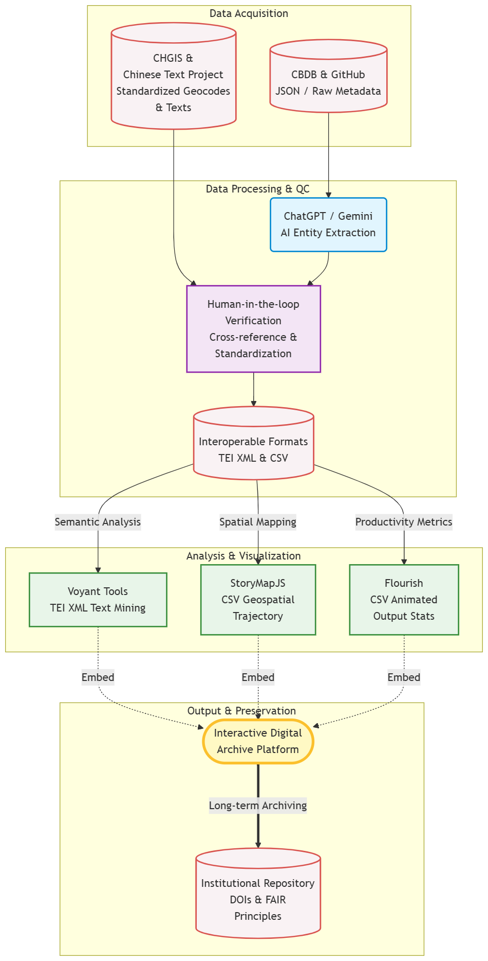

Primary Academic Data Sources
The project draws upon four specialized digital repositories to reconstruct the life and literature of the Tang era. We extract biographical markers and life events from the China Biographical Database, which serves as a massive relational archive managed by Harvard and Peking University. The poetic corpus comes from the chinese poetry repository on GitHub, providing nearly one thousand works attributed to Li Bai in a format suitable for computational processing. To ensure spatial accuracy, we utilize the China Historical GIS system for standardized geocodes that reflect the administrative boundaries of the eighth century. Finally, the Chinese Text Project facilitates high quality verification of these materials by providing access to digital transcriptions and scanned rare book images.
Data Types and Interoperable Formats
Since the research involves diverse media, we utilize specific formats to maintain interoperability and ensure long term accessibility. Poetic texts are primarily handled in JSON for initial processing and subsequently converted into Markdown or TEI XML for deeper semantic analysis. Spatial information resides in structured CSV files to support the mapping of the poet's twenty five thousand mile journey across the Tang empire. We also maintain biographical timelines in relational formats to facilitate the visualization of his life stages. By choosing open and non proprietary standards, the project guarantees that the research results can be easily shared and interpreted by various software environments without loss of data integrity.
Quality Control and AI Assisted Preprocessing
Transforming classical Chinese into machine ready data requires a multi stage cleaning process to mitigate the risk of errors. While generative artificial intelligence models are effective at identifying place names and recurring imagery within the verses, they remain prone to historical inaccuracies. Consequently, the data steward implements a human in the loop verification protocol where all AI generated labels are cross referenced with authoritative gazetteers. We also apply a standardization protocol to the poet's various names and honorary titles to prevent duplicate entries in our database. This rigorous quality control ensures that the resulting visualizations are grounded in verifiable facts rather than automated hallucinations.
Collaborative Storage and Preservation Strategy
Success within a five person team depends on a standardized organizational logic and clear communication. We maintain a hierarchical folder system on a shared drive, carefully separating raw archives from working analysis files and final dissemination products. Every document follows a chronological naming convention based on dates and keywords, which prevents version conflicts as the team prepares the infographic. Sustainable digital scholarship also relies on a commitment to long term viability. We prioritize the use of persistent identifiers, such as Digital Object Identifiers, to ensure that our datasets remain findable and citable. Final outputs will be deposited in institutional repositories that provide regular fixity checking and archival support according to the FAIR principles.

Long term Preservation and Scholarly Sustainability
Sustainable digital scholarship relies on more than simple backups; it requires a commitment to the long term viability of the research. We prioritize the use of persistent identifiers, such as Digital Object Identifiers, to ensure that our datasets remain findable and citable even if the project website changes. Final outputs will be deposited in institutional repositories that provide regular fixity checking and archival support. Furthermore, we adhere to the FAIR principles to ensure that our data is accessible and reusable for the broader academic community. This focus on sustainability protects the project's legacy and ensures that the digital reconstruction of Li Bai's life remains a resource for future generations.

Ethical Considerations
One potential ethical issue in this project is AI bias and historical inaccuracy. Since our project uses generative AI tools such as ChatGPT or Gemini to process Li Bai’s poems and biographical records, the system may incorrectly identify historical dates, place names, or poetic meanings. This is especially important because classical Chinese texts often contain ambiguous expressions, old geographical names, and symbolic imagery. If these errors are not carefully checked, the final timeline, map, or data visualization may present a misleading picture of Li Bai’s life and literary development.
To reduce this risk, our group will apply a human verification process. All AI-generated labels, extracted locations, and thematic interpretations will be cross-checked with reliable academic sources such as CBDB, historical gazetteers, and verified literary texts before being used in the final infographic or platform. In this way, AI will function only as an assistive tool for data processing, while the final interpretation and presentation remain under human academic judgment.
Risk: AI bias and historical inaccuracy
Issue: AI may misidentify dates, places, or meanings in Li Bai’s texts
Impact: This may create misleading maps and timelines
Mitigation: Verify AI-generated results with trusted academic sources
Principle: AI is a support tool, while final judgment remains human-led

